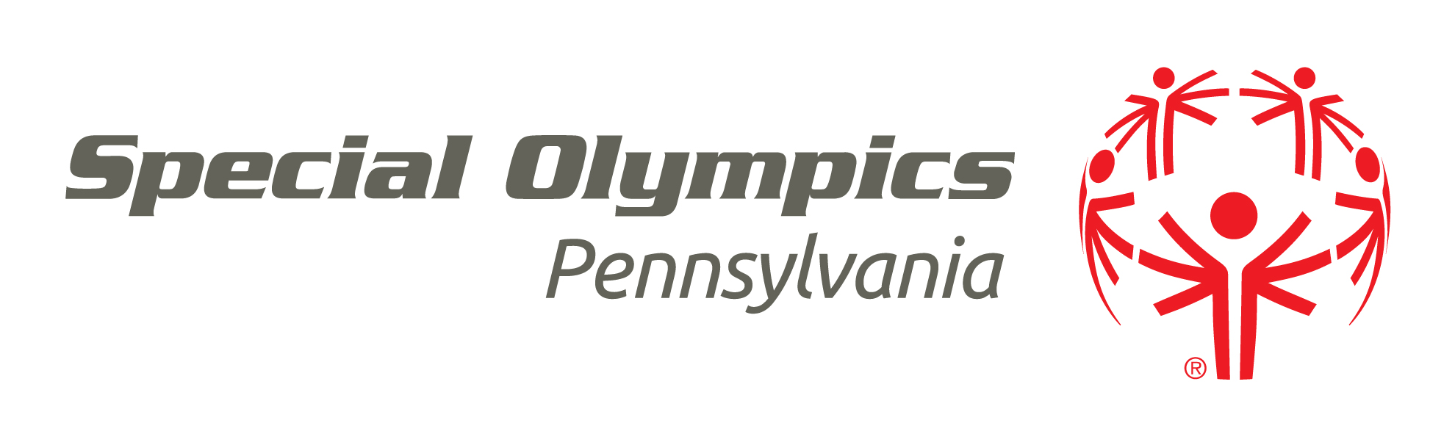
SPORTS TRAINING APPLICATION

**NEW SKILLS SPORT CERTIFICATION ONLY

Instructions: Please print clearly and return to the address at the bottom of this application.

1. List the information requested in the boxes below (please print your name as it appears in the SOPA Database):
Name: | Address:
City: | State: Zip:
Daytime/Cell Phone: ( ) | Local Program (COUNTY):
E-mail address:
If your address has changed since your last certification, please check this box. ◻

2. Sport Skill from Training– ________ __ This training course was held on
___/___/____ at_______________________
Date Location/City/State
PRACTICUM (For Track 1 and 2 Only)
- A minimum of 10 hours working with Special Olympics Athletes in the sport listed above is required to complete your Level 2 Certification.
- Up to five hours of coaching, with a certified coach during the training season that is taking place prior to the course. (ex. if you have 5 training sessions before you take your sport training, you may use 5 hours from this time as long as you were coaching under a certified coach)
- No more than three hours may be used from coaching during a competition (no matter how many days).

DATE
# of Hours
# of Athletes

3. To complete your certification please ensure you have taken the following trainings and they are up to date:

√if  completed | On-Line Course | Link | When Expires:
 | Protective Behaviors | http://www.specialolympics.org/protective_behaviors.aspx | Must be renewed every three years
 | Concussion Training | https://nfhslearn.com/courses/38000 | Must be renewed every three years
 | General Orientation | http://www.specialolympicspa.org/ways-to-help/volunteer/general-orientation | Lifetime certification

4. Having satisfactorily completed all requirements, I hereby request Special Olympics certification in the area identified above.

_________________________________ ____/____/____ _________________________________ ____/___/______
Signature of Applicant/Coach Date Signature of Practicum Supervisor Date
(Local Training Coordinator)

